DATE | 18 November 2022
TEAM ID | PNT2022TMID45483
PROJECT NAME | Project-Signs with smart connectivity for better road safety
PROJECT PHASE DEVELOPMENT | SPRINT 2

PYTHON PROGRAM

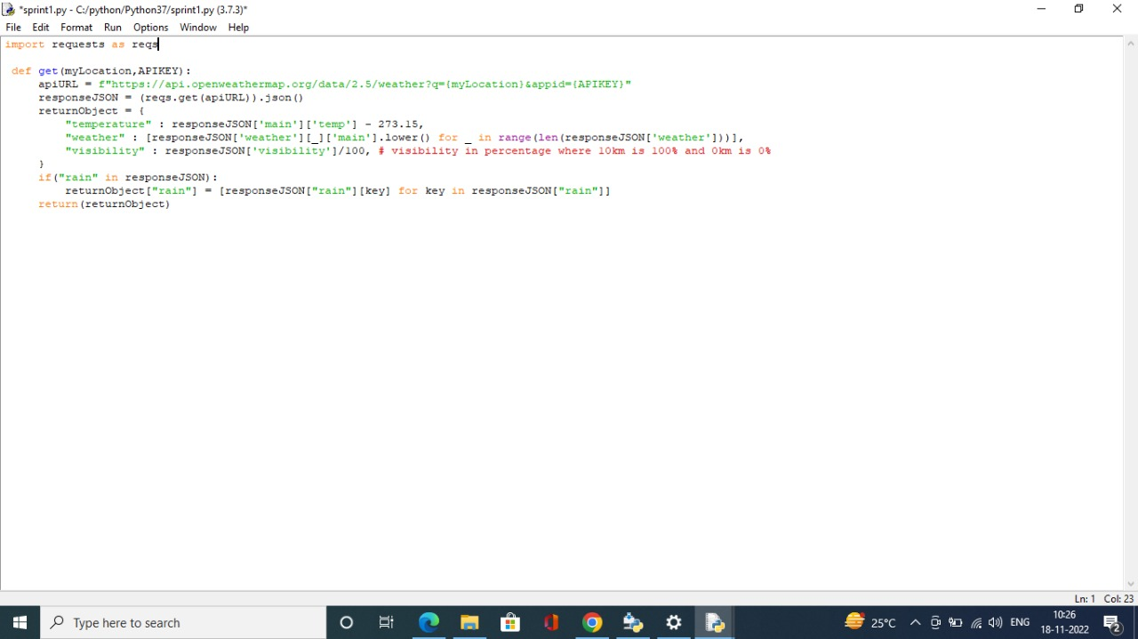

BRAIN PYTHON
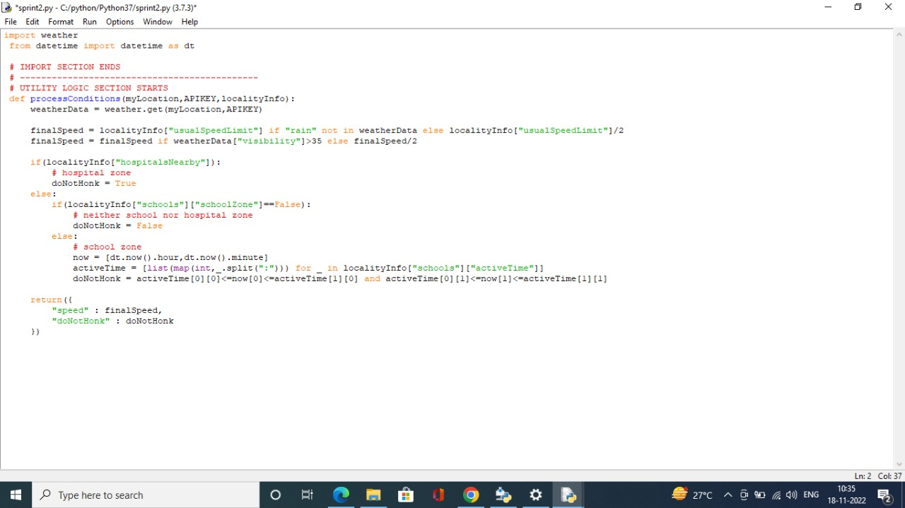
MAIN PYTHON
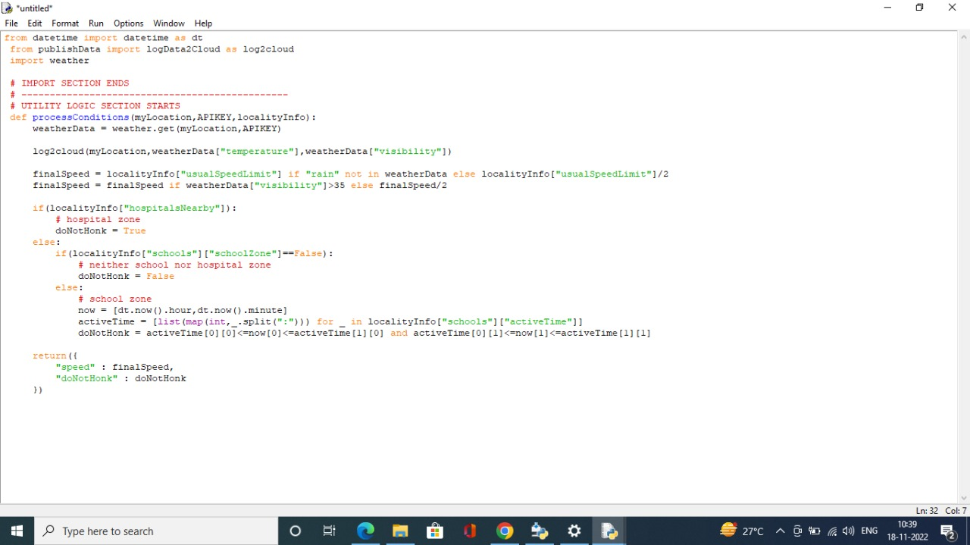

OUTPUT
